Application Setup – Demo App

By: Larry Ranches

Email: [rancheslp@outlook.com](mailto:rancheslp@outlook.com)

**Note: Screen Sheets are in Visual Studio 2013**

Setup up DemoApp.Web

1. On the DemoApp.Web project, right click and select properties
2. Under the Web option > Start Action. Select specific page and enter #/home.

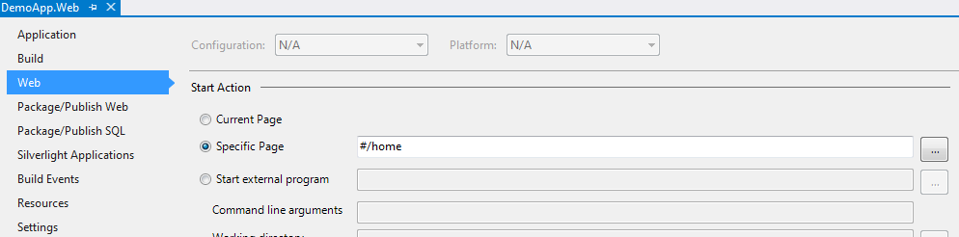

1. Set DemoApp.Web as startup project.

App folder structure in .Web

